Bandit level 9 to level 10
To login to the level 9 use the username as
And then use ls command to list the files.
And then getting the file use strings data.txt | grep "=" command which means extracts readable text from the file and display the lines containing =.
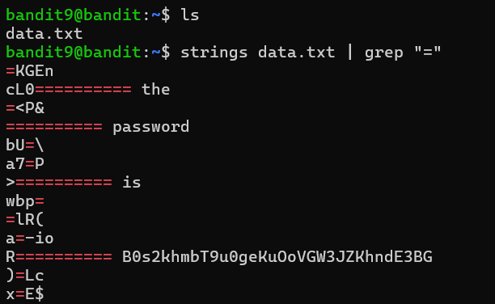
After this command it contains the password for the next level

